To: All Engineering Staff Date: 9.11.21
From: Yvonne
Toolbox Talk: Head Injuries

Brain injury is more common than you think, and its impact can be life-changing for both the individual hurt but also their wider family. Ensuring your head protection is worn and cared for correctly is key to remaining safe.

Worker injuries
However, the sad fact remains that head injuries still occur on UK construction sites. In the UK, according to RIDDOR statistics (published on 30 October by the Health and Safety Executive), being struck on the head by moving, flying or falling objects accounted for 13 per cent of worker deaths from 2014-19, and 10 per cent of all non-fatal injuries in 2019.
The main reason for the injuries (and worse) is that operatives are still likely to take off their hard hats if they are feeling uncomfortable. Remember that a humble hard hat or bump cap could save your life, so please wear it!
Hard hats/ Bump caps should be replaced after a significant impact or within 5 years and should be tested to the EN397 standard. Look after your hard hats and bump caps so that they can look after YOU in the event of an accident. It is there to protect people…you.
Danger of Rotational Forces
The brain will be impacted by both linear and rotational forces but the brain in more sensitive to rotational forces. This is because the brain is similar to water, it is more sensitive to rotational acceleration. Pure linear acceleration could damage the brain, due to it not being a perfect sphere, but then the impact energy would need to be much higher than the energy that could cause a rotational motion, and those forces can transfer to your brain.
Accident statistics show that 30% of slips, trips and falls from height or on the same level occur, which could suffer a rotational injury. Therefore, consider using a hard hat with a chin strap as the hat needs to stay on your head to be able to protect you.

Please remember if your hard hat/bump cap is not on your head, it can’t protect you!
https://www.hse-network.com/wear-your-hard-hat-urges-brain-injury-charity/
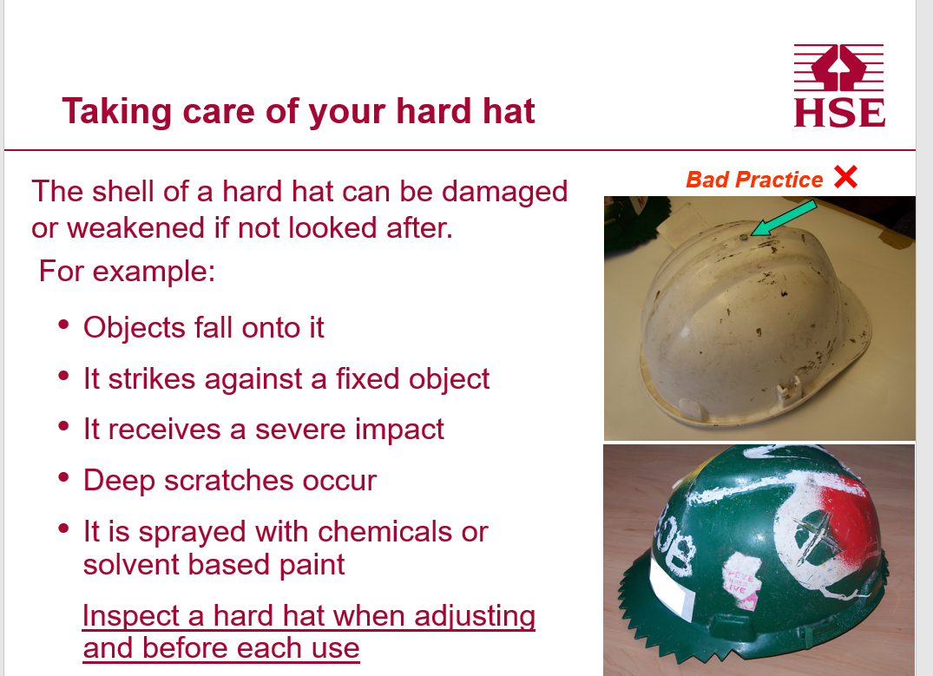
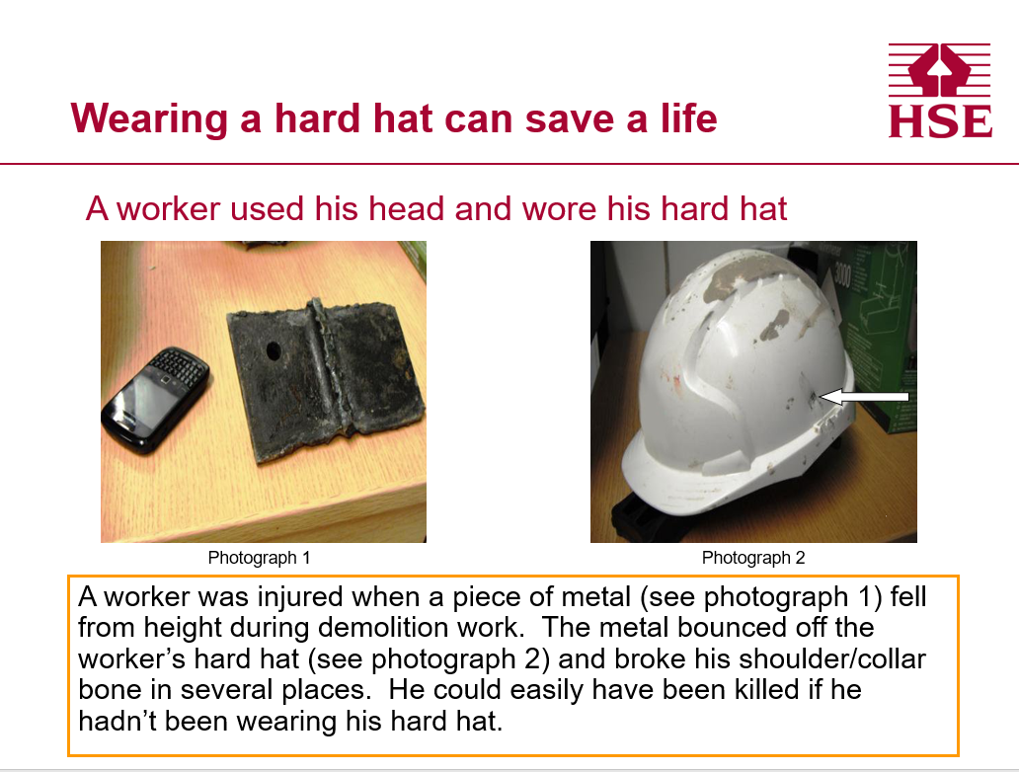

Hard Hats saves lives – wear them!

